Programming Exercise 4: The **kwargs List
Pedro Clavero De Dios
March 1, 2026
COP 2373

Section 4.8.2 - The **kwargs List
The following screenshots show the code from section 4.8.2 of the textbook executed in IPython. The **kwargs parameter allows a function to accept an arbitrary number of keyword arguments, which are packed into a dictionary.

IPython Screenshots

SCREENSHOT 1 – print info function definition and calls
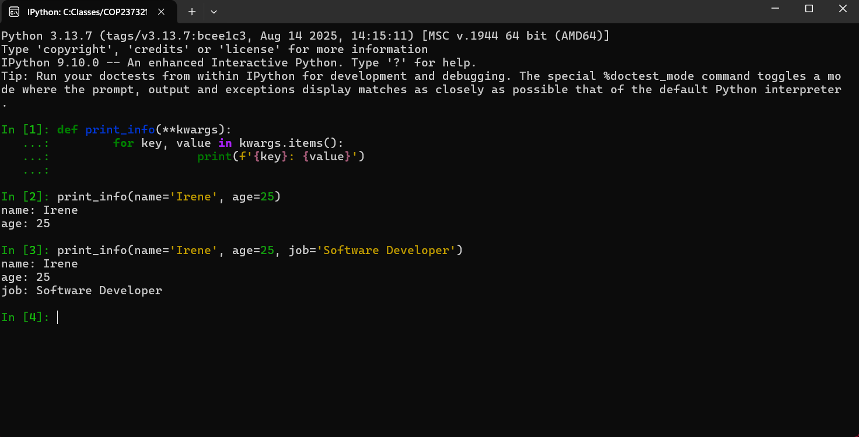
SCREENSHOT 2 – build profile function and output
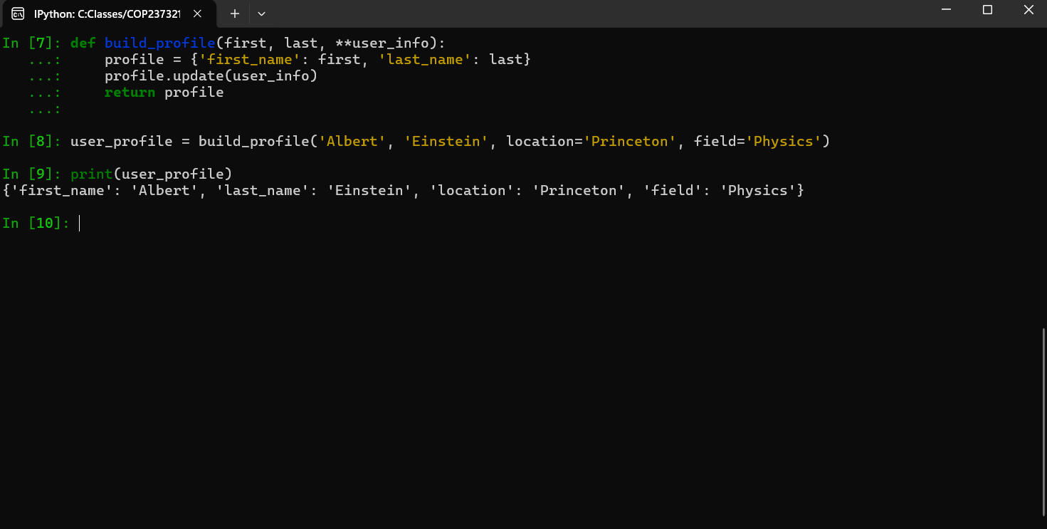
SCREENSHOT 3 - display_student function and output
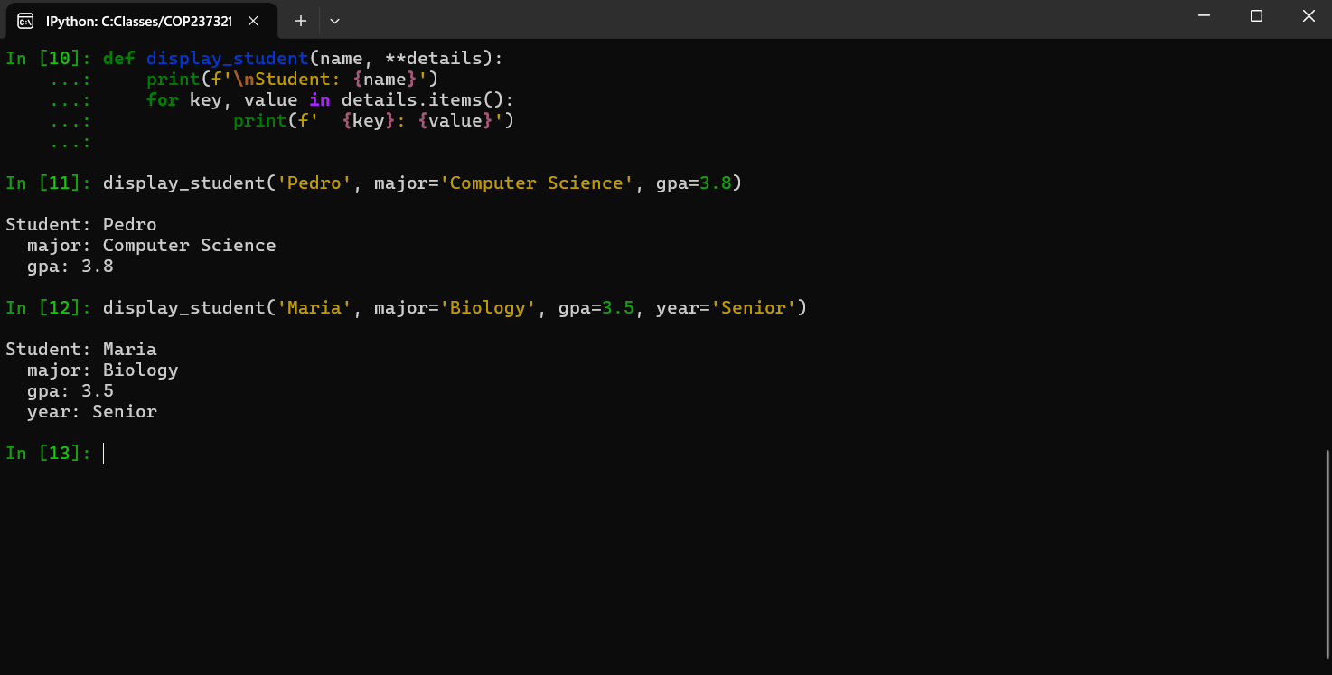

Advantages and Disadvantages of Using **kwargs

Advantages
1. **kwargs allows a function to accept any number of keyword arguments without defining each parameter ahead of time.
2. Instead of listing many optional parameters, **kwargs keeps the function signature short and readable.
3. **kwargs makes it easy to forward keyword arguments from one function to another, which is useful in wrapper functions and decorators.

Disadvantages
1. It is not clear right away what arguments the function expects, since they aren’t listed in the function definition.
2. Python doesn’t raise an error if you pass a misspelled keyword argument through **kwargs, making bugs harder to catch.
3. Most IDEs can’t provide auto-complete suggestions for **kwargs parameters since the accepted keywords are not explicitly defined.

Repo
GitHub Repo Link: https://github.com/Pclav34/PC_COP2373

